W3 – Data Manipulation

Save your W3 notebook with the following naming conventions.
ID_Name_SecNo_W3.ipynb,
for example
6113333_JohnWick_541_W3.ipynb

What is Pickle? (.p or .pkl)
Pickle is a serialized way of storing a Pandas dataframe. Basically, you are writing down the exact representation of the dataframe to disk. This means the types of the columns are and the indices are the same. Download taxi_owners.p and load the data using pd.read_pickle()
taxi_owner = pd.read_pickle('taxi_owners.p')
taxi_owner.head()

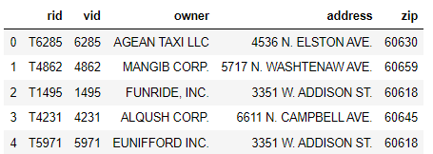
Today we will be working with Pickle files as well. Back to that soon.
There are several ways to store data for analysis, but rectangular data, sometimes called "tabular data" is the most common form. In this example, with dogs, each observation, or each dog, is a row, and each variable, or each dog property, is a column.
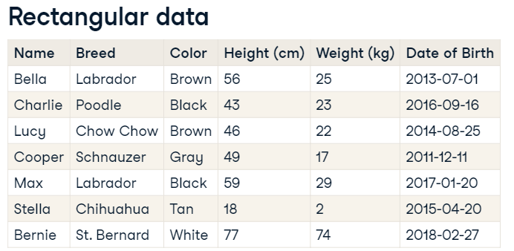
Exploring a DataFrame can be done by many methods such as .head(), .info(). The .info() method displays the names of columns, the data types they contain, and whether they have any missing values.
df.describe() | The describe method computes some summary statistics for numerical columns, like mean and median. "count" is the number of non-missing values in each column. describe is good for a quick overview of numeric variables
df.shape | The shape attribute contains a tuple that holds the number of rows followed by the number of columns.
df.values | The values attribute contains the data values in a 2-dimensional NumPy array.
df.columns | The columns attribute contains column names.
df.index | The index attribute contains row numbers or row names.

Let’s try them all. Load homelessness.csv to homelessness DataFrame and explore the data.

Sorting and Subnetting (Filtering) – We did some in the previous worksheet. Let’s dig deeper.
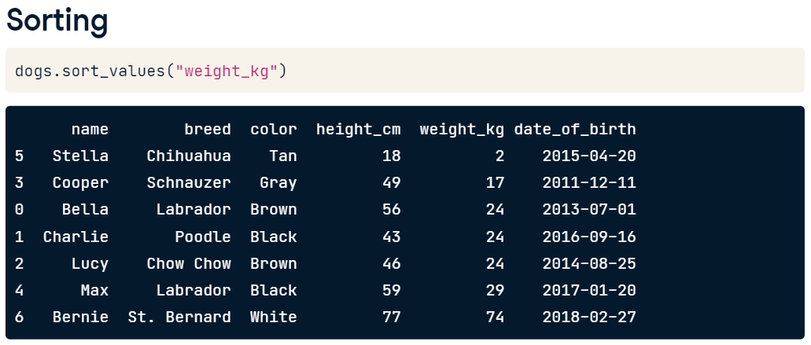
Setting the ascending argument to False will sort the data the other way around, from heaviest dog to lightest dog.
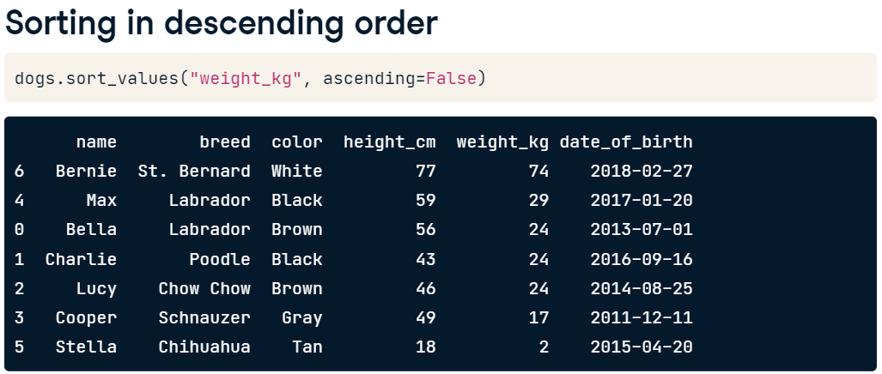
We can sort with multiple variables. You need to pass a list of variables as an argument.
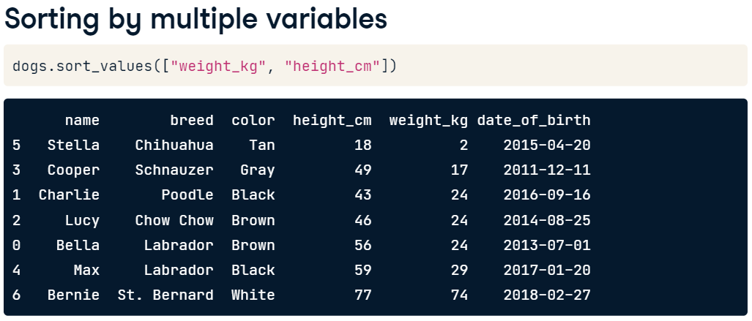
To change the direction values are sorted in, pass a list to the ascending argument to specify which direction sorting should be done for each variable.
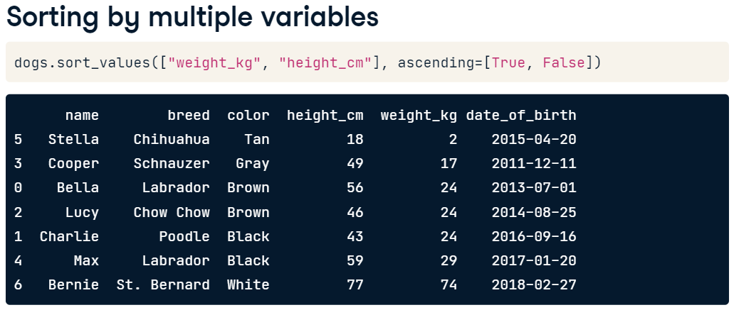
Selecting column(s) or subsetting column(s) can be done as follows.
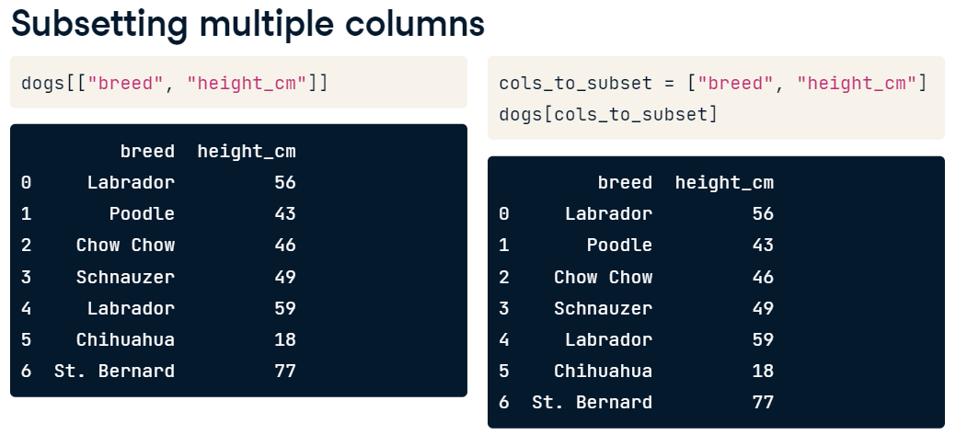
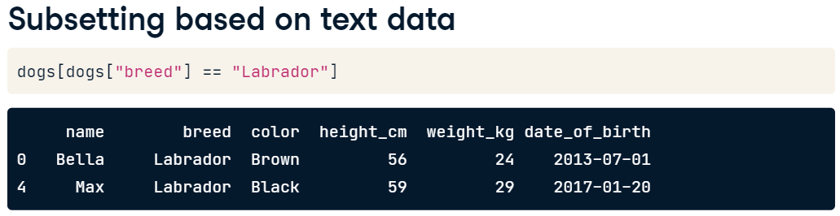
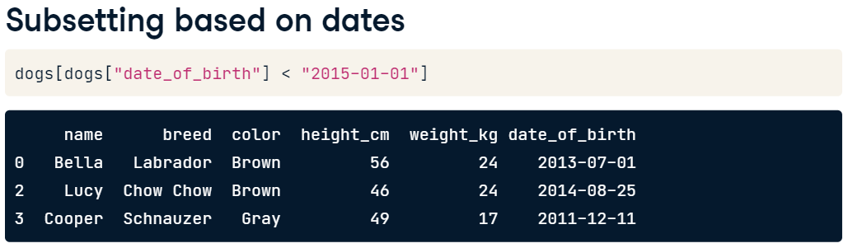
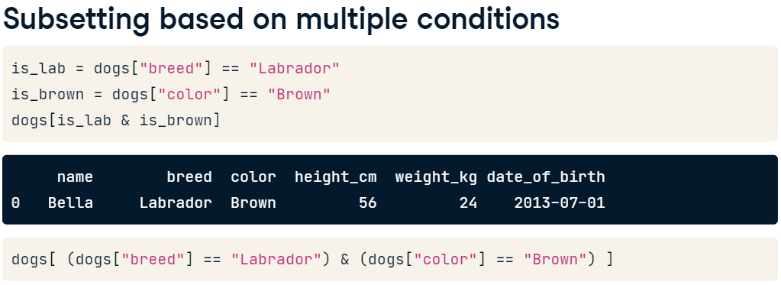
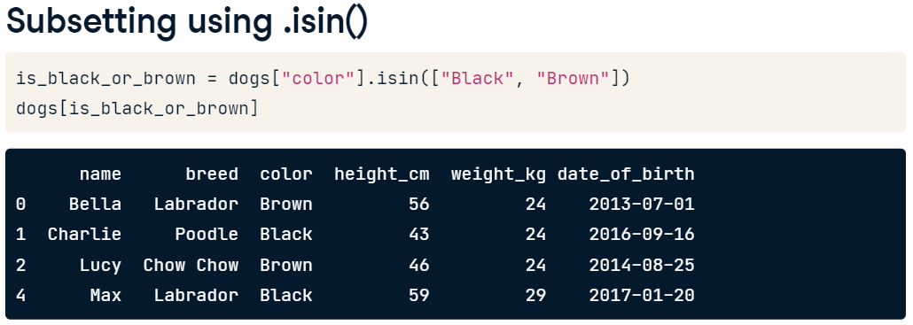
Let’s practice with homelessness DataFrame. Load homelessness.csv into homelessness
- Sort homelessness by the number of homeless individuals, from smallest to largest, and save this as homelessness_ind. Print the head of the sorted DataFrame.
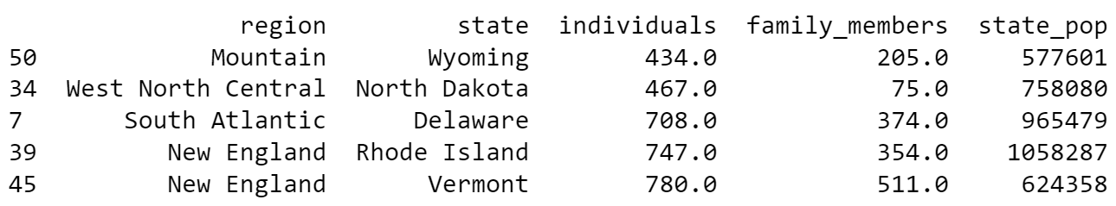
- Sort homelessness by the number of homeless family_members in descending order, and save this as homelessness_fam. Print the head of the sorted DataFrame.
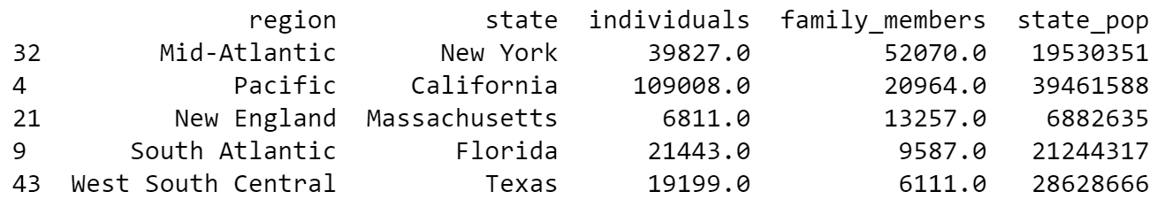
- Sort homelessness first by region (ascending), and then by number of family members (descending). Save this as homelessness_reg_fam. Print the head of the sorted DataFrame.
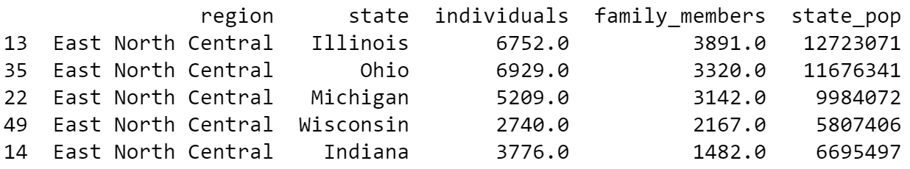
- Create a DataFrame called state_fam that contains only the state and family_members columns of homelessness, in that order. Print the head of the result.
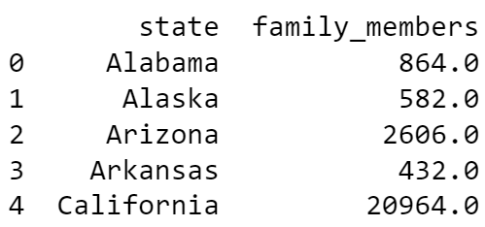
Let’s subset rows.
- Filter homelessness for cases where the number of individuals is greater than ten thousand, assigning to ind_gt_10k. View the printed result.

- Filter homelessness for cases where the USA Census region is "Mountain", assigning to mountain_reg. View the printed result.

- Filter homelessness for cases where the number of family_members is less than one thousand and the region is "Pacific", assigning to fam_lt_1k_pac. View the printed result.

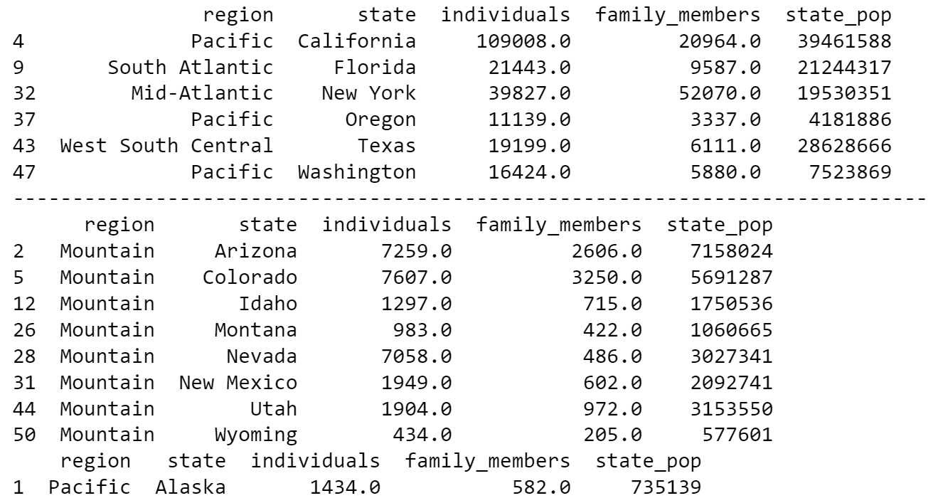
- Filter homelessness for cases where the USA census region is "South Atlantic" or it is "Mid-Atlantic", assigning to south_mid_atlantic. View the printed result.
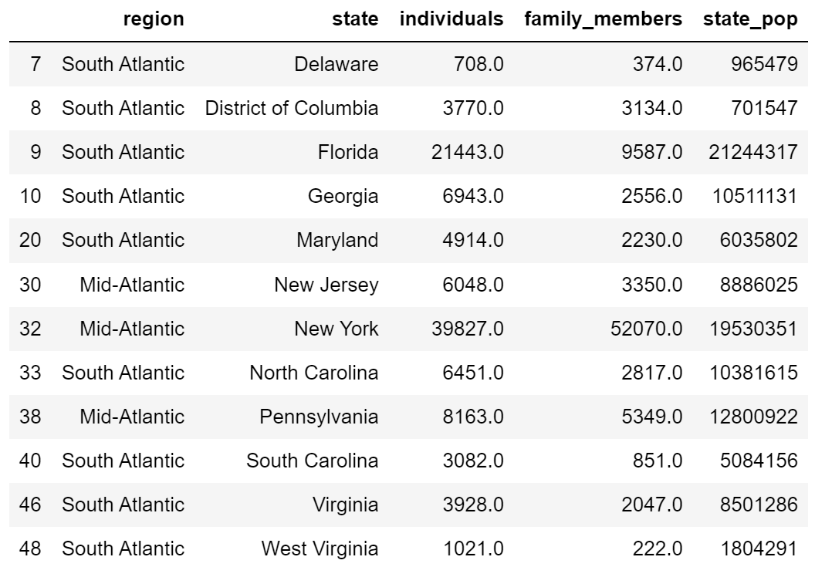
- Filter homelessness for cases where the USA census state is in the list of Mojave states, canu, assigning to mojave_homelessness. View the printed result.
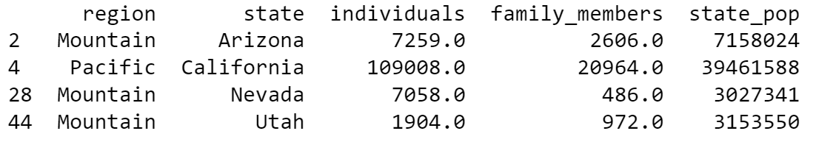
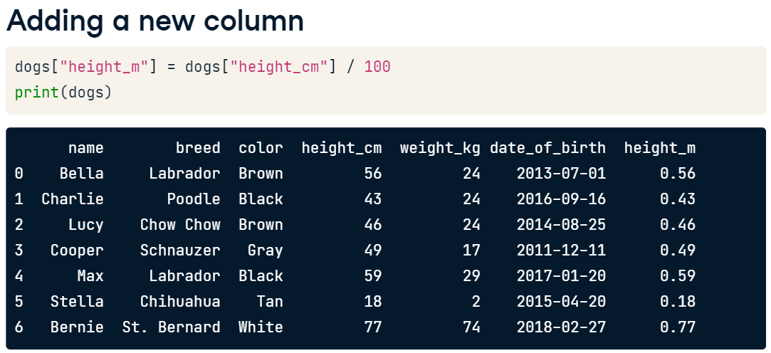
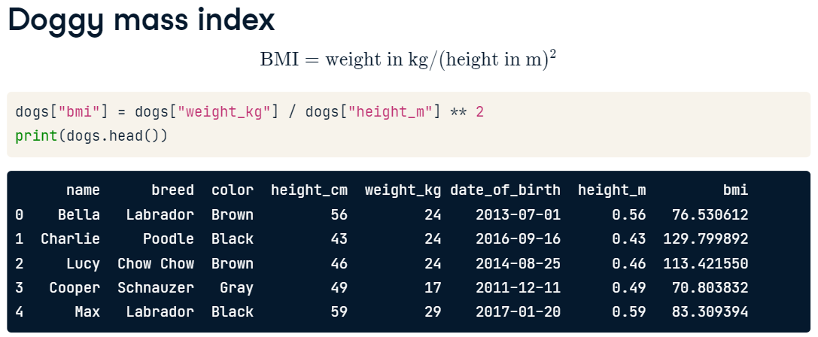
Let’s add new columns.
- Add a new column to homelessness, named total, containing the sum of the individuals and family_members columns. (Not all rows are shown. There should be 50 rows in total.)
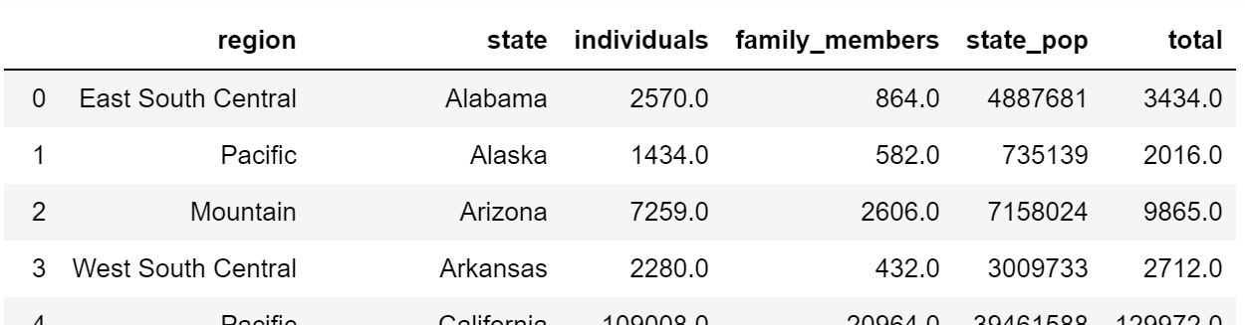

- Add another column to homelessness, named p_individuals, containing the proportion of homeless people in each state who are individuals.
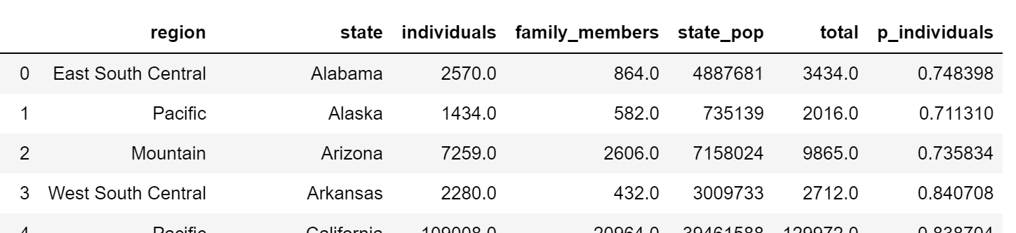
- Combo Attack…..

  - Add a column to homelessness, indiv_per_10k, containing the number of homeless individuals per ten thousand people in each state.

Hint: 10000 * homelessness['individuals'] / homelessness['state_pop']

  - Subset rows where indiv_per_10k is higher than 20, assigning to high_homelessness.

  - Sort high_homelessness by descending indiv_per_10k, assigning to high_homelessness_srt.

  - Select only the state and indiv_per_10k columns of high_homelessness_srt and save as result. Look at the result.
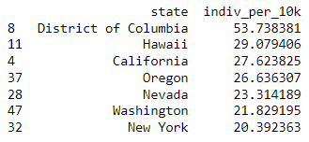

Summary Statistics with Pandas
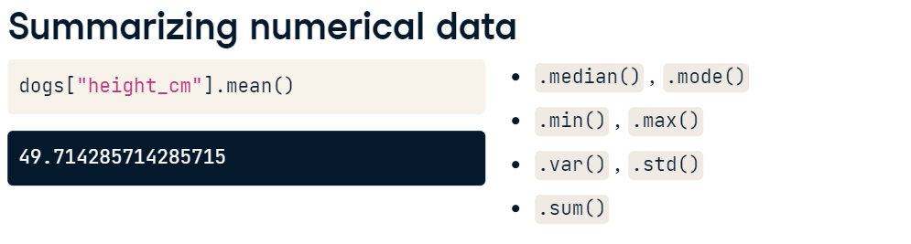
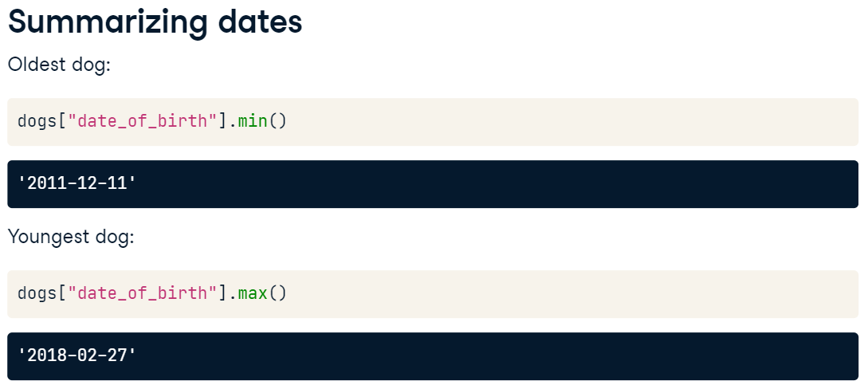

Writing your own function is also possible.
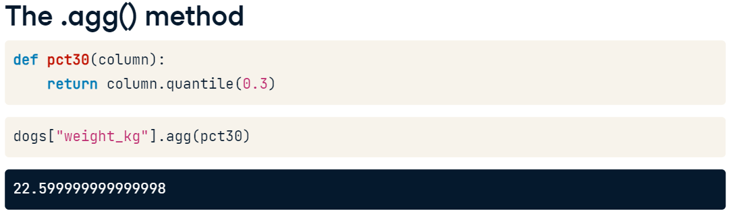
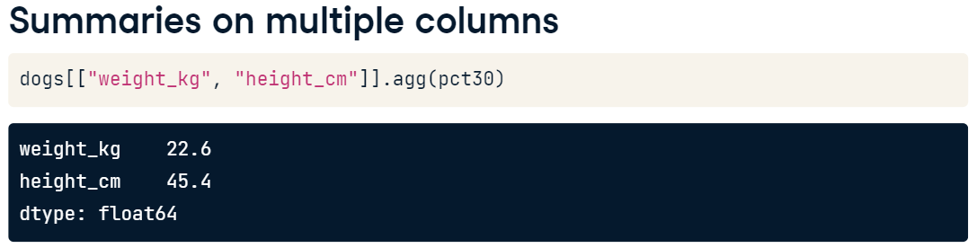
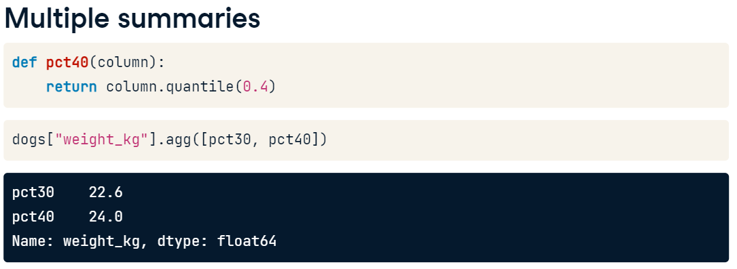
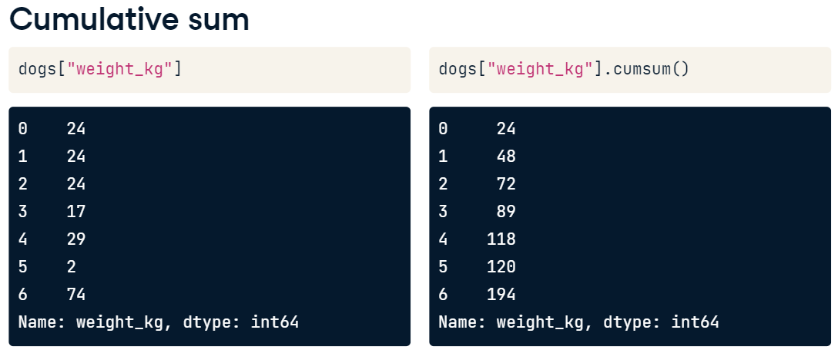

Let’s Practice.
Load sales_subset.csv to sales and try the following codes.
# Print the head of the sales DataFrame
print(sales.head())

# Print the info about the sales DataFrame
print(sales.info())

# Print the mean of weekly_sales
print(sales['weekly_sales'].mean())

# Print the median of weekly_sales
print(sales['weekly_sales'].median())

# Print the maximum of the date column
print(sales['date'].max())

# Print the minimum of the date column
print(sales['date'].min())

We are going to see more about .cumsum() and .cummax() with the following codes.
You need to create a DataFrame, sales_1_1, which contains the sales data for department 1 of store 1.
sales_1_1 = sales[(sales[‘deparment’] == ……) & (…………………) ]
# Sort sales_1_1 by date
sales_1_1 = sales_1_1.sort_values('date', ascending = True)

# Get the cumulative sum of weekly_sales, add as cum_weekly_sales col
sales_1_1['cum_weekly_sales'] = sales['weekly_sales'].cumsum()

# Get the cumulative max of weekly_sales, add as cum_max_sales col
sales_1_1['cum_max_sales'] = sales['weekly_sales'].cummax()

# See the columns you calculated
print(sales_1_1[["date", "weekly_sales", "cum_weekly_sales", "cum_max_sales"]])

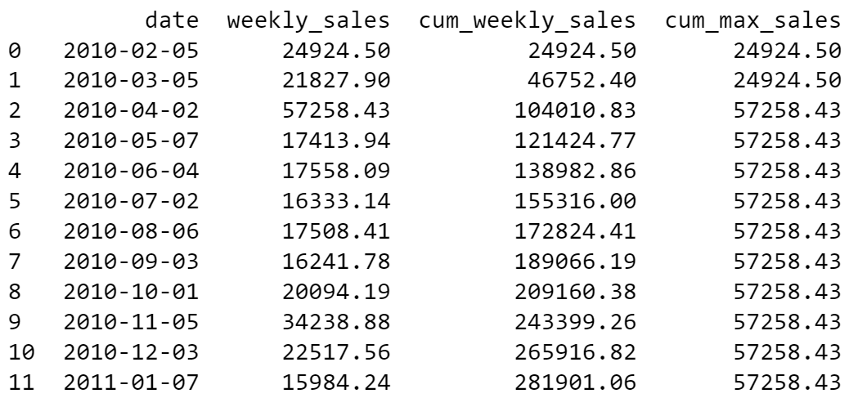

Dropping Duplicates – It is possible that the data set contains duplicated values and sometimes we do not want to have them in the analysis.
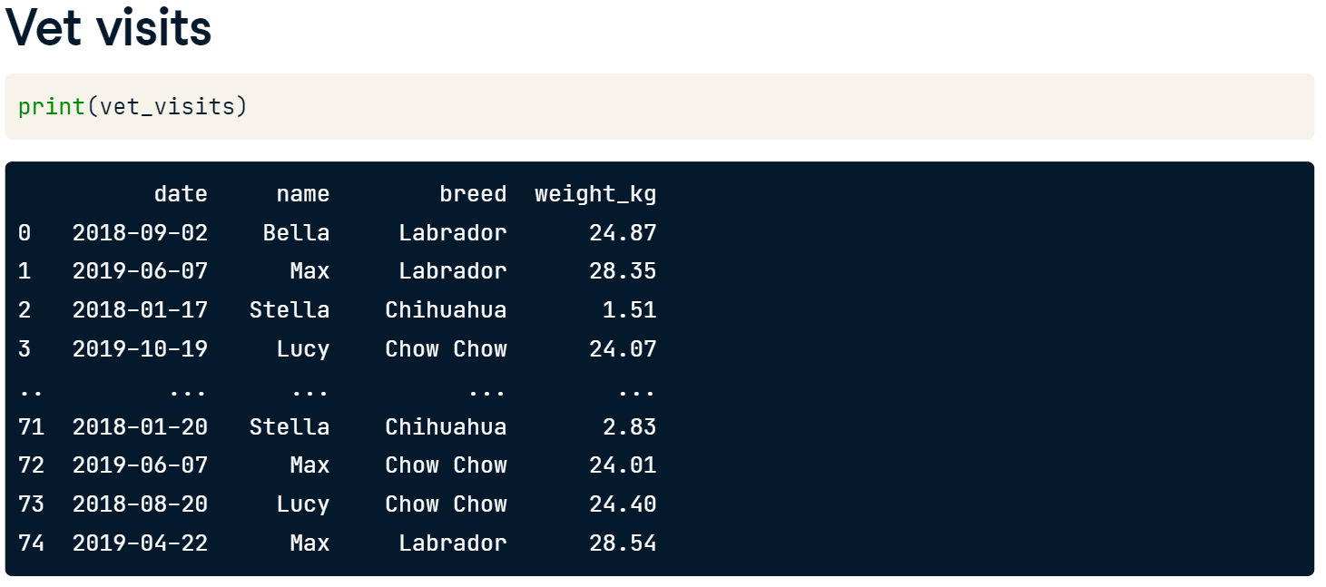
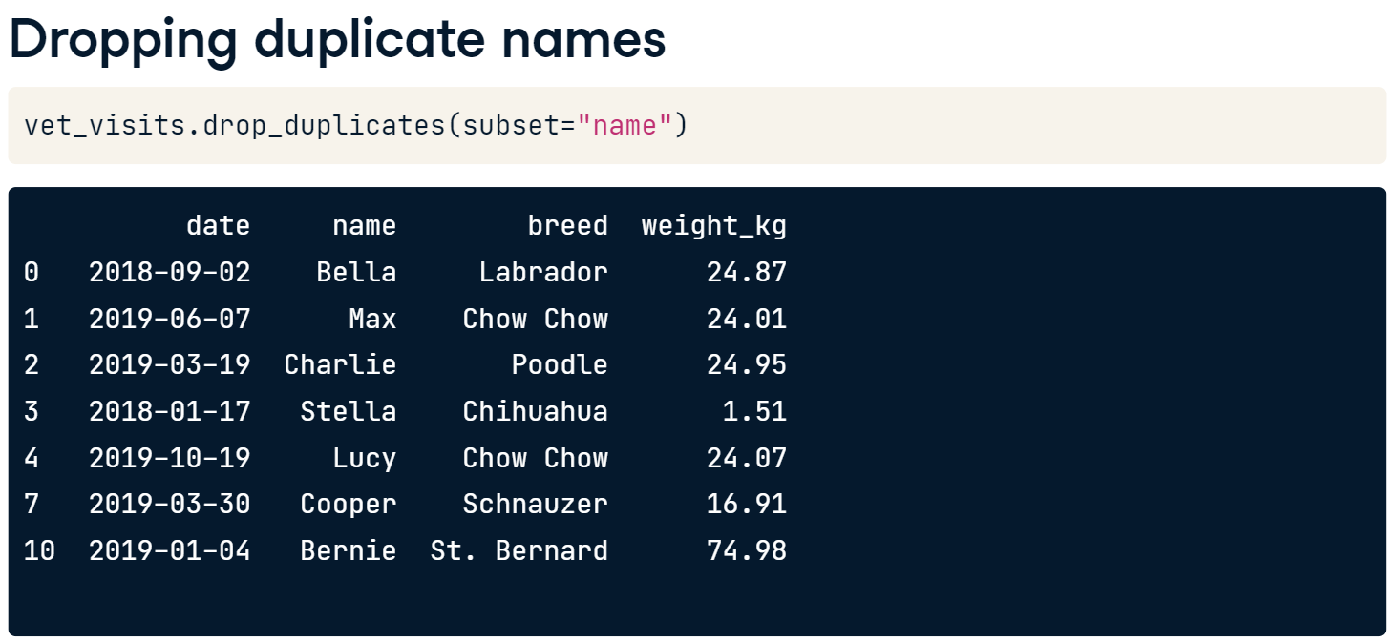
Since Max and Max are different breeds, we can drop the rows with pairs of name and breed listed earlier in the dataset.
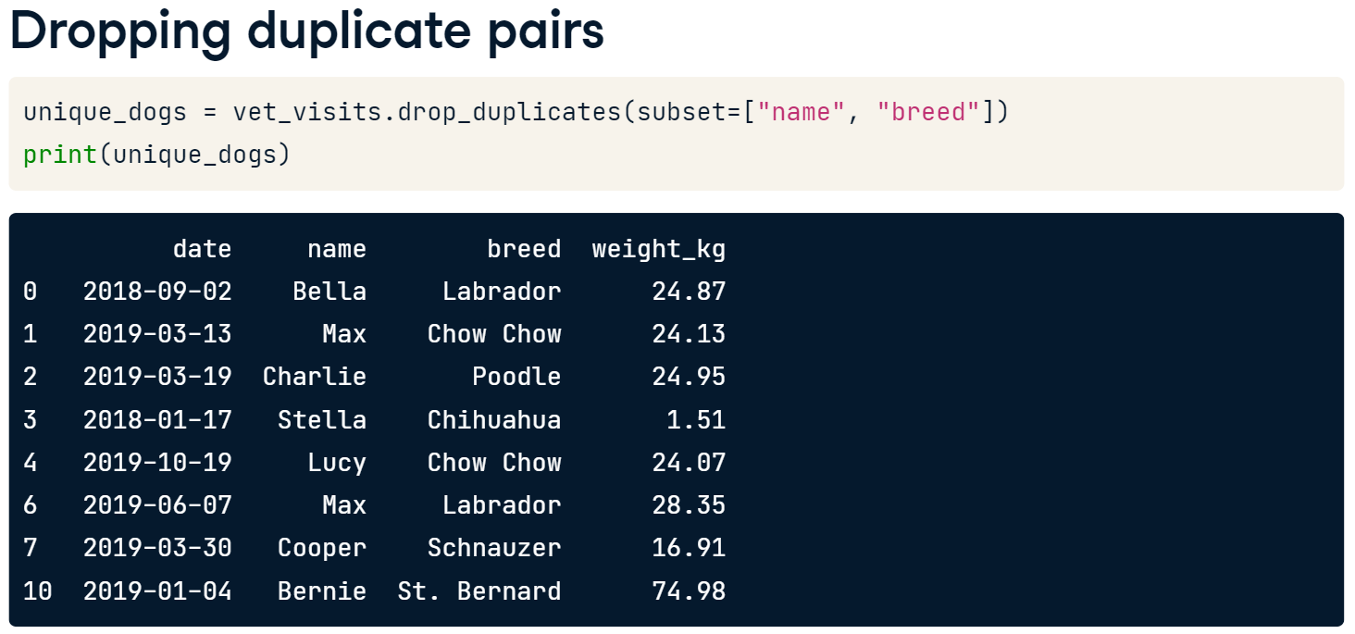
After dropping duplicates, you may want to count the values.
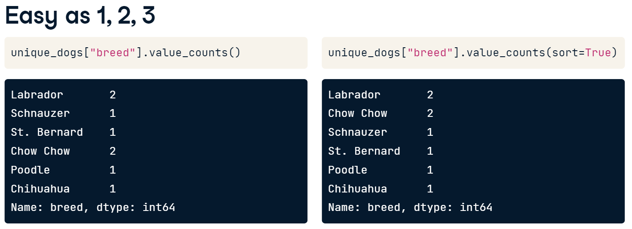
Normalization helps us to understand data better. The normalize argument can be used to turn the counts into proportions of the total. 25% of the dogs that go to this vet are Labradors.
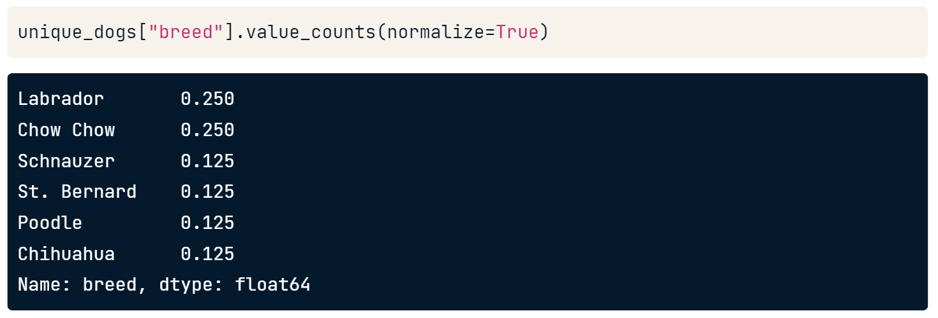
Let’s practice.
- Dropping Duplicates
- Remove rows of sales with duplicate pairs of store and type and save as store_types and print the head.
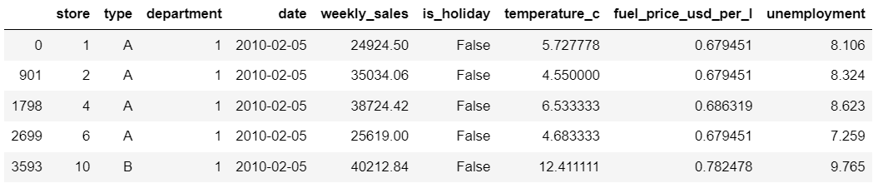
- Remove rows of sales with duplicate pairs of store and department and save as store_depts and print the head.
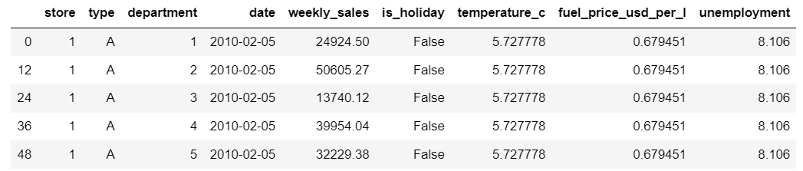
- Subset the rows that are holiday weeks using the is_holiday column, and drop the duplicate dates, saving as holiday_dates.
- Select the date column of holiday_dates, and print.
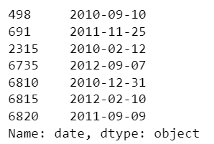

- Counting and Normalization
- Count the number of stores of each store type in store_types.
- Count the proportion of stores of each store type in store_types.
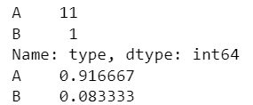
- Count the number of different departments in store_depts, sorting the counts in descending order.
- Count the proportion of different departments in store_depts, sorting the proportions in descending order.
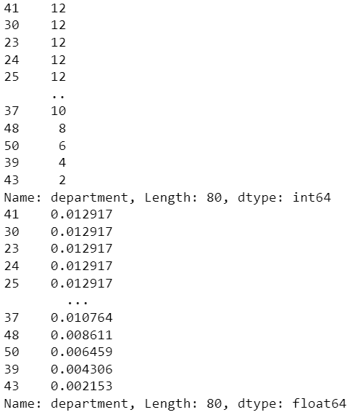

Summaries by Group (.groupby() method)
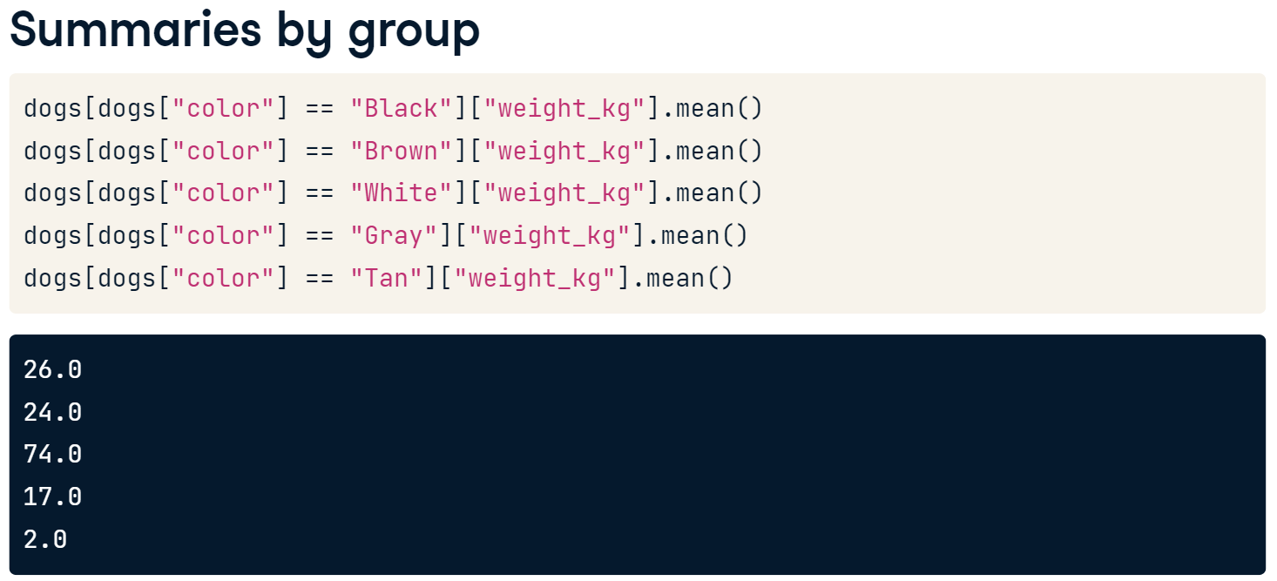
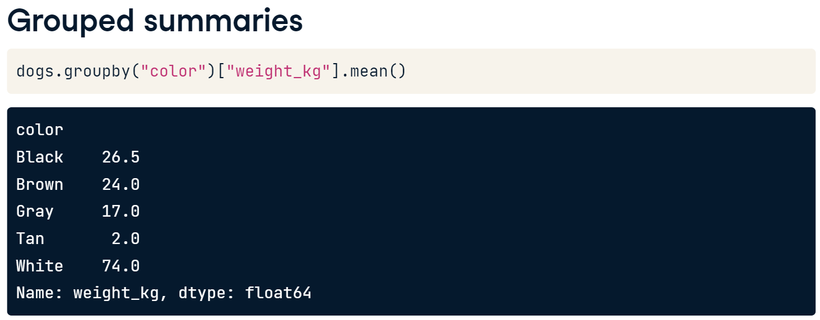
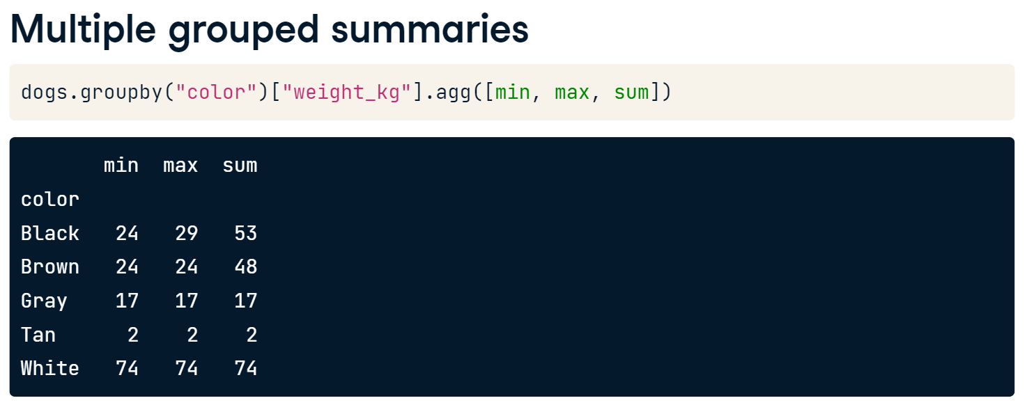
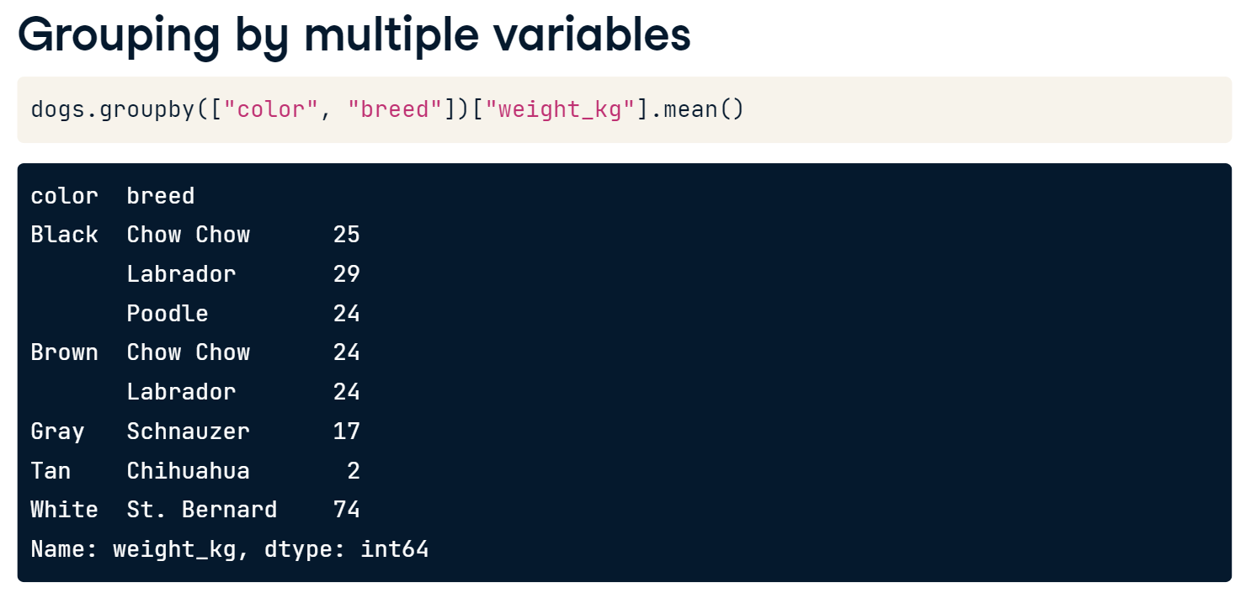
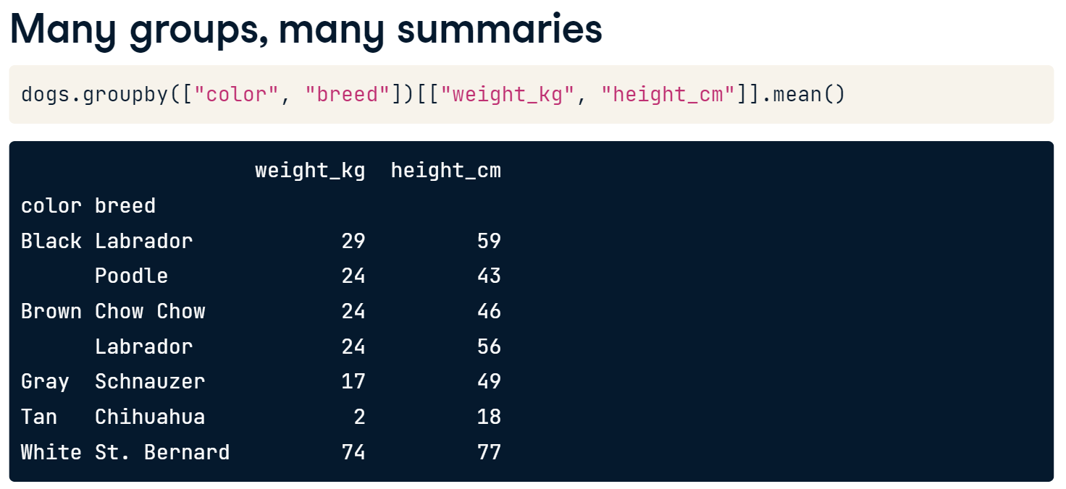

Let’s see how multiple grouped summaries work. Try the following codes.
# Calc total weekly sales
sales_all = sales["weekly_sales"].sum()

# Subset for type A stores, calc total weekly sales
sales_A = sales[sales["type"] == "A"]["weekly_sales"].sum()

# Subset for type B stores, calc total weekly sales
sales_B = sales[sales["type"] == "B"]["weekly_sales"].sum()

# Subset for type C stores, calc total weekly sales
sales_C = sales[sales["type"] == "C"]["weekly_sales"].sum()

# Get proportion for each type
sales_propn_by_type = [sales_A, sales_B, sales_C] / sales_all
print(sales_propn_by_type)

- What do you see in the result? Analyze the data and answer the question in your opinion.

Now let’s try the following codes.
# Import numpy with the alias np
import numpy as np

# For each store type, aggregate weekly_sales: get min, max, mean, and median
sales_stats = sales.groupby('type')['weekly_sales'].agg([min, max, np.mean, np.median])

# Print sales_stats
print(sales_stats)

# For each store type, aggregate unemployment and fuel_price_usd_per_l: get min, max, mean, and median
unemp_fuel_stats = sales.groupby('type')[['unemployment','fuel_price_usd_per_l']].agg([min, max, np.mean, np.median])

# Print unemp_fuel_stats
print(unemp_fuel_stats)
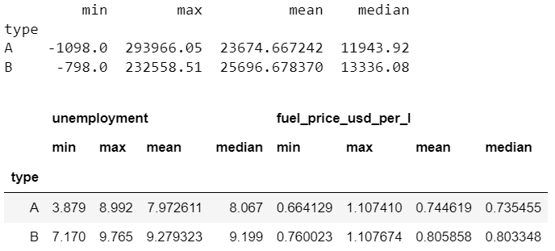

Pivot Table
Pivot tables are another way of calculating grouped summary statistics. If you've ever used a spreadsheet, chances are you've used a pivot table. Let's see how to create pivot tables in pandas.
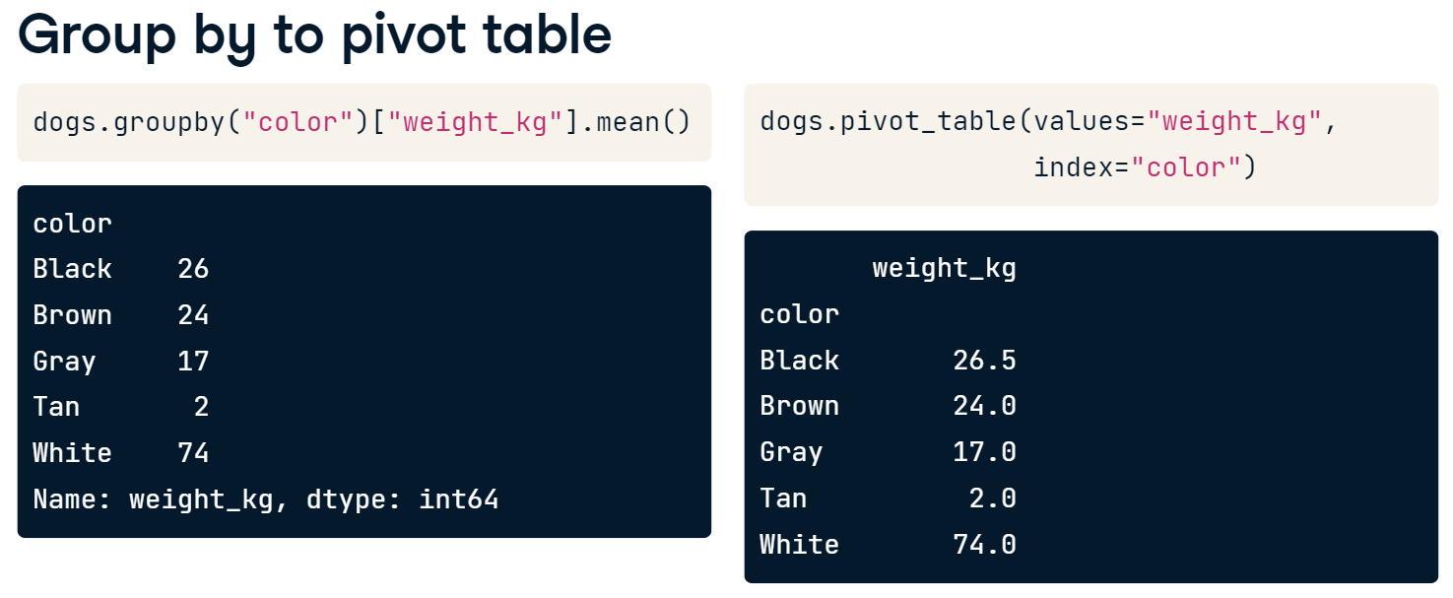
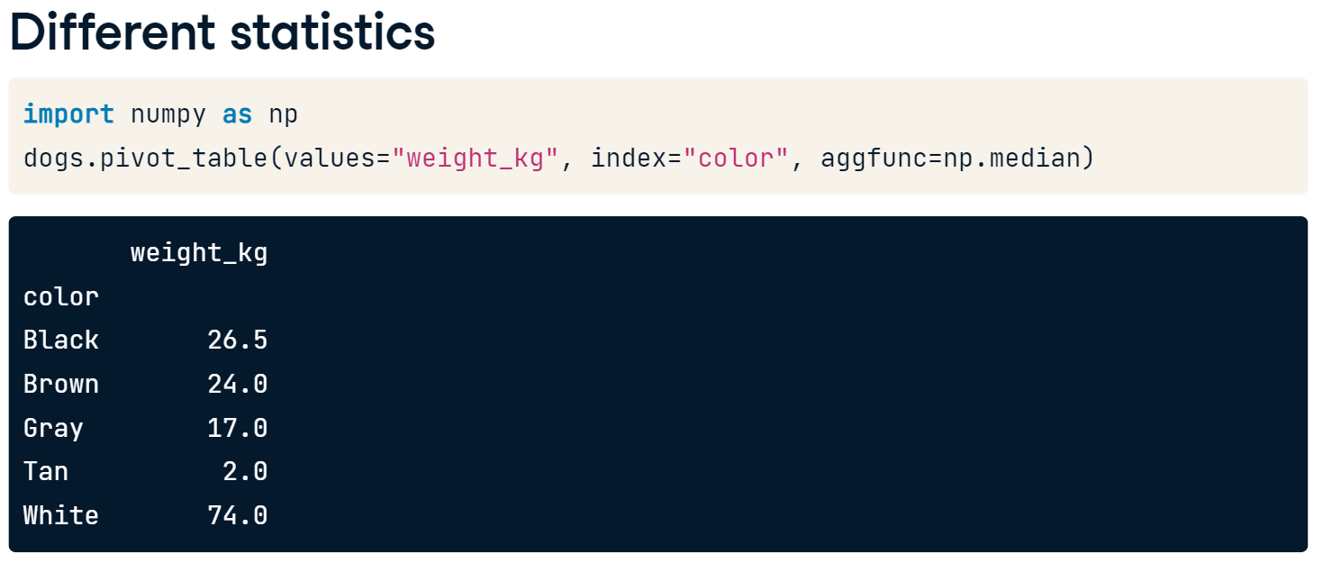
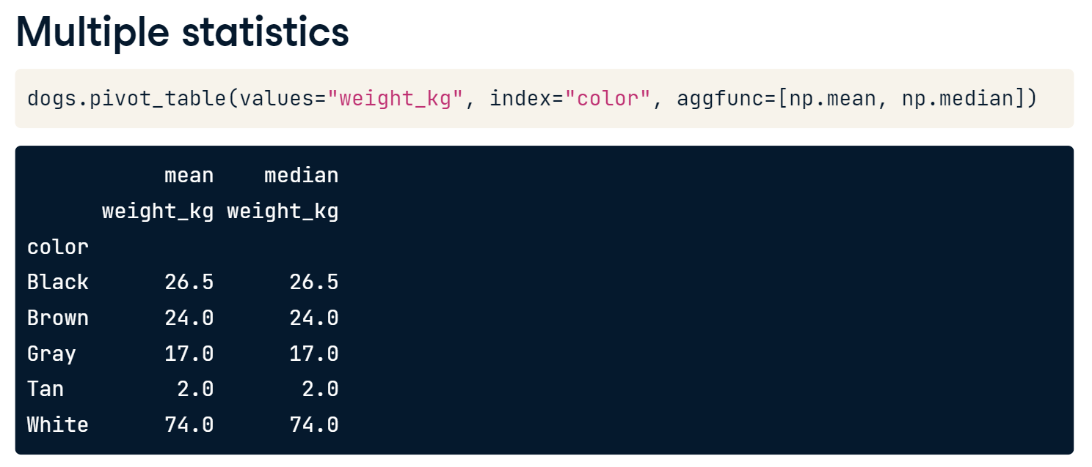

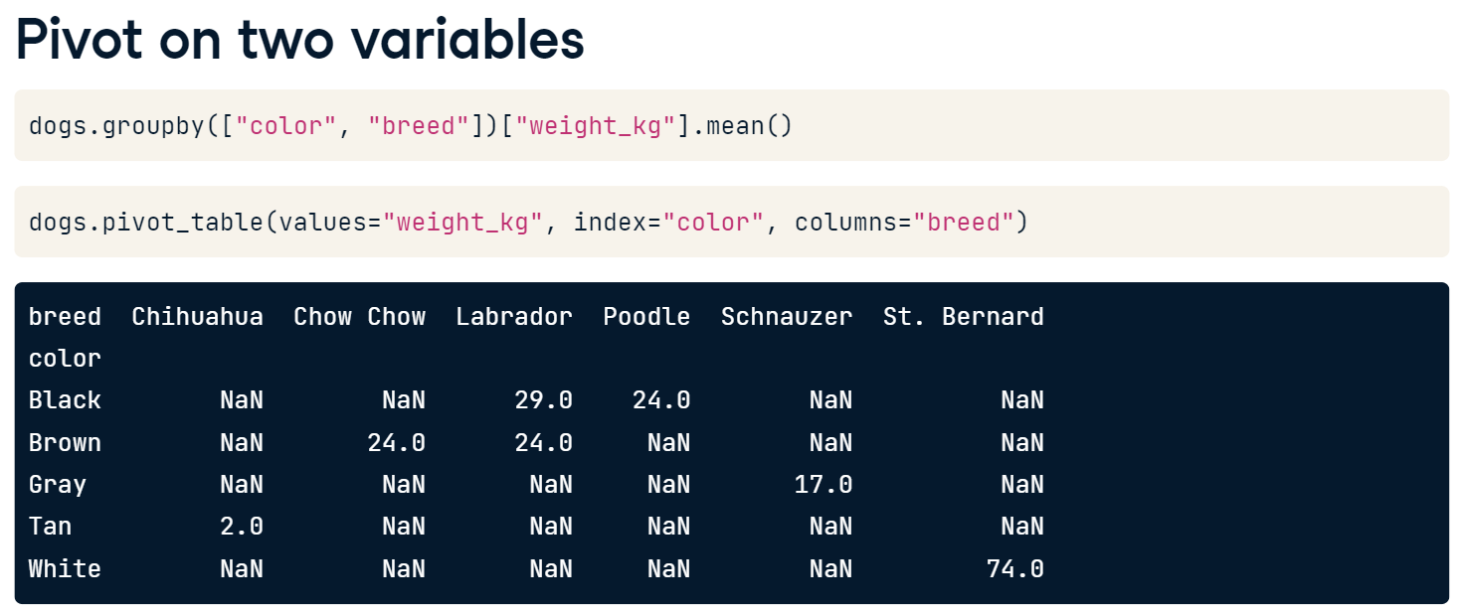
You also previously computed the mean weight grouped by two variables: color and breed. We can also do this using the pivot_table method. To group by two variables, we can pass a second variable name into the columns argument.
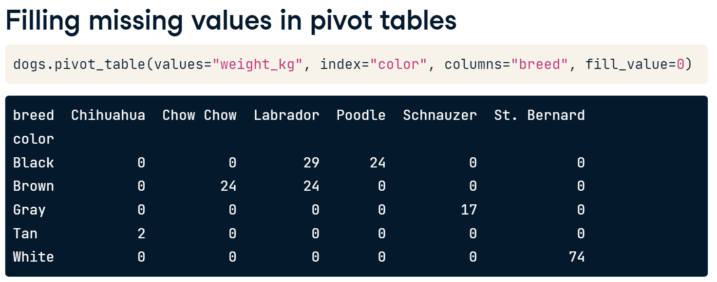
If we set the margins argument to True, the last row and last column of the pivot table contain the mean of all the values in the column or row, not including the missing values that were filled in with 0s. For example, in the last row of the Labrador column, we can see that the mean weight of the Labradors is 26 kilograms. In the last column of the Brown row, the mean weight of the Brown dogs is 24 kilograms. The value in the bottom right, in the last row and last column, is the mean weight of all the dogs in the dataset. Using margins equals True allows us to see a summary statistic for multiple levels of the dataset: the entire dataset, grouped by one variable, by another variable, and by two variables.
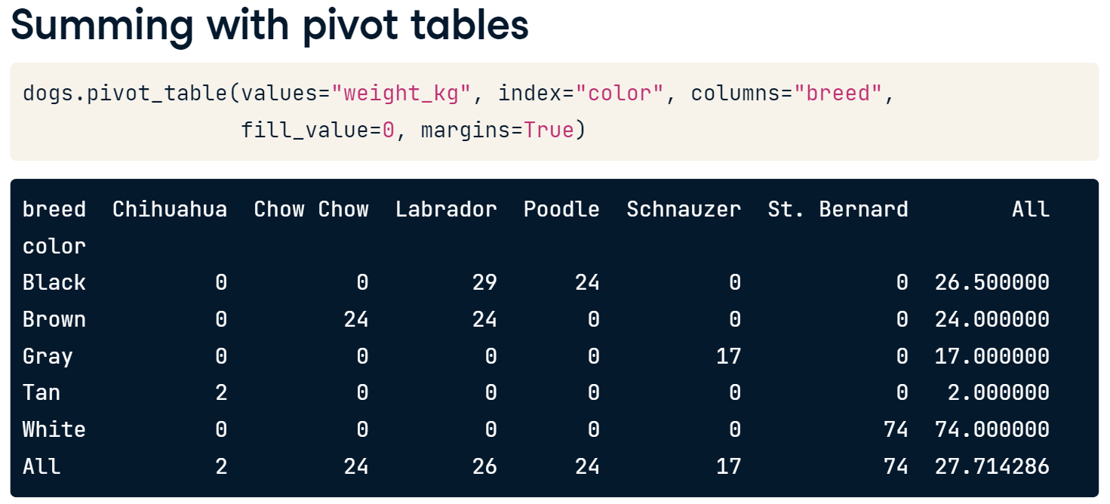
Try
# Print mean weekly_sales by department and type; fill missing values with 0
print(sales.pivot_table(values = 'weekly_sales', index = 'department', columns = 'type', fill_value = 0))

Multi-level Indexes (Hierarchical Indexes)
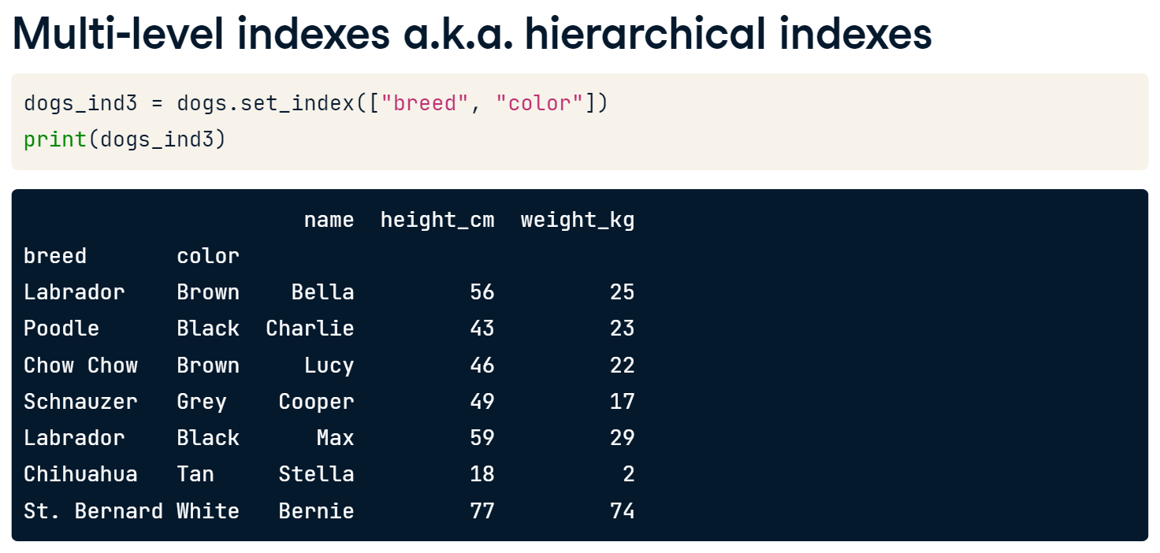
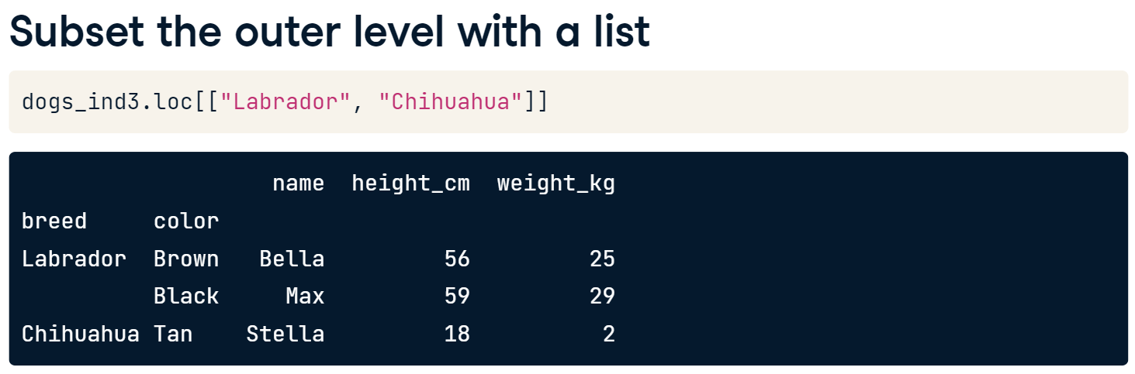
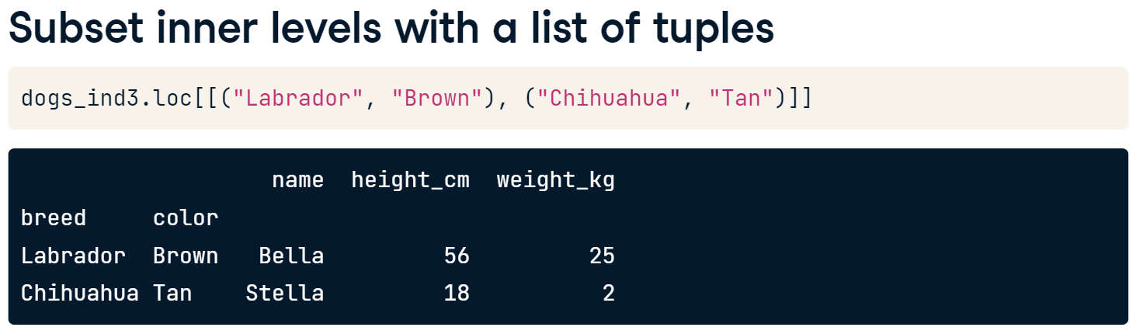
Let’s see some examples.

Load temperatures.csv to temperatures dataframe and try the following codes.
# Look at temperatures
print(temperatures)
# Set the index of temperatures to city
temperatures_ind = temperatures.set_index('city')

# Look at temperatures_ind
print(temperatures_ind)

# Reset the temperatures_ind index, keeping its contents
print(temperatures_ind.reset_index())

# Reset the temperatures_ind index, dropping its contents
print(temperatures_ind.reset_index(drop = True))
# Make a list of cities to subset on
cities = ["Moscow", "Saint Petersburg"]

# Subset temperatures using square brackets
print(temperatures[temperatures['city'].isin(cities)])

# Subset temperatures_ind using .loc[]
print(temperatures_ind.loc[cities])

- Complete the following tasks.
- Set the index of temperatures to the "country" and "city" columns, and assign this to temperatures_ind.
- Specify two country/city pairs to keep: "Brazil"/"Rio De Janeiro" and "Pakistan"/"Lahore", assigning to rows_to_keep.
- Print and subset temperatures_ind for rows_to_keep using .loc[].
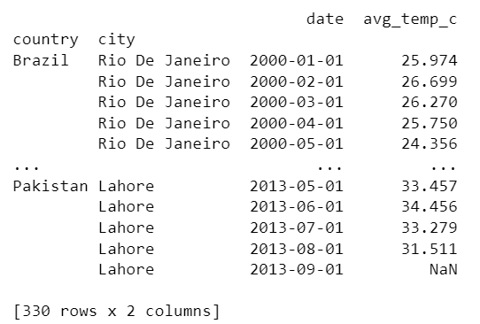

Layering Plots
Let’s see what we can do if we have overlapping plots.
Load avoplotto.pkl (pickle file) to avocados dataframe and try the following.
# Import matplotlib.pyplot with alias plt
import matplotlib.pyplot as plt

# Look at the first few rows of data
print(avocados.head())

# Get the total number of avocados sold of each size
nb_sold_by_size = avocados.groupby('size')['nb_sold'].sum()

# Create a bar plot of the number of avocados sold by size
nb_sold_by_size.plot(kind = 'bar')

# Show the plot
plt.show()

# Get the total number of avocados sold on each date
nb_sold_by_date = avocados.groupby('date')['nb_sold'].sum()

# Create a line plot of the number of avocados sold by date
nb_sold_by_date.plot(kind='line', rot = 45)

# Show the plot
plt.show()

# Scatter plot of avg_price vs. nb_sold with title
avocados.plot(x='nb_sold', y='avg_price', kind = 'scatter', title = 'Number of avocados sold vs. average price')

# Show the plot
plt.show()

# Histogram of conventional avg_price
avocados[avocados['type'] == 'conventional']['avg_price'].plot(kind = 'hist')

# Histogram of organic avg_price
avocados[avocados['type'] == 'organic']['avg_price'].plot(kind = 'hist')

# Add a legend
plt.legend(['conventional','organic'])

# Show the plot
plt.show()

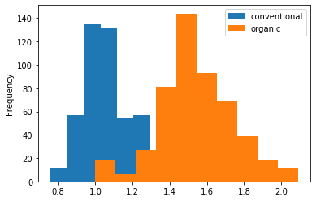 Add alpha = 0.6 in plot() and run again.

Missing Values in DataFrame
In a pandas DataFrame, missing values are indicated with N-a-N, which stands for "not a number."
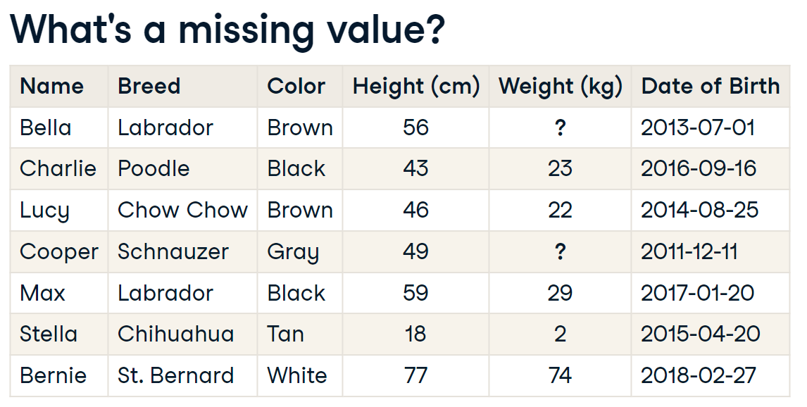

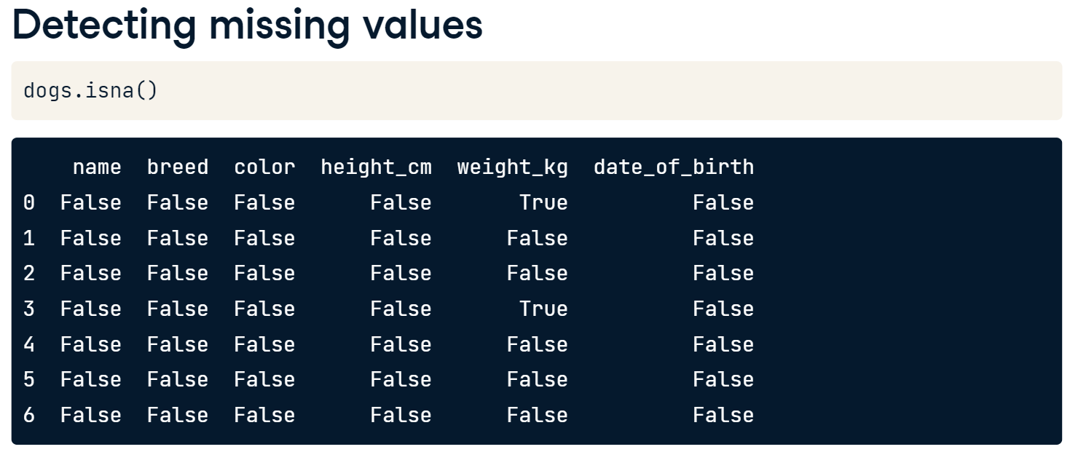
If we chain dot-isna with dot-any, we get one value for each variable that tells us if there are any missing values in that column.
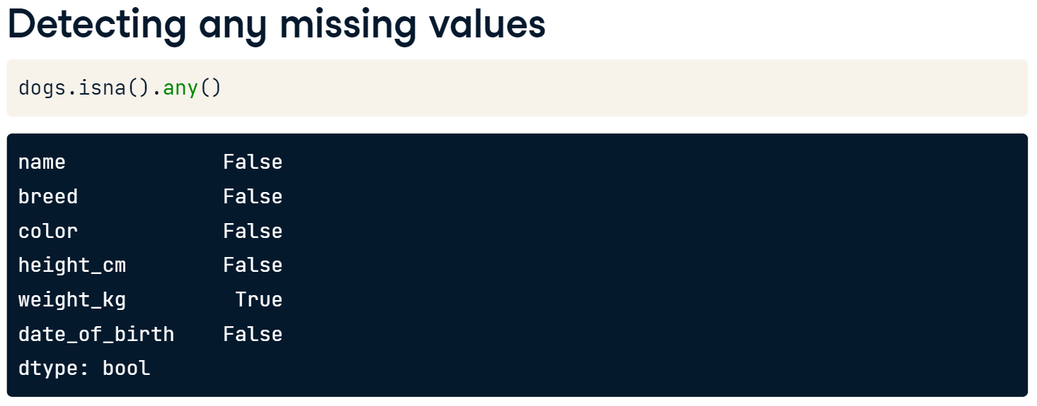
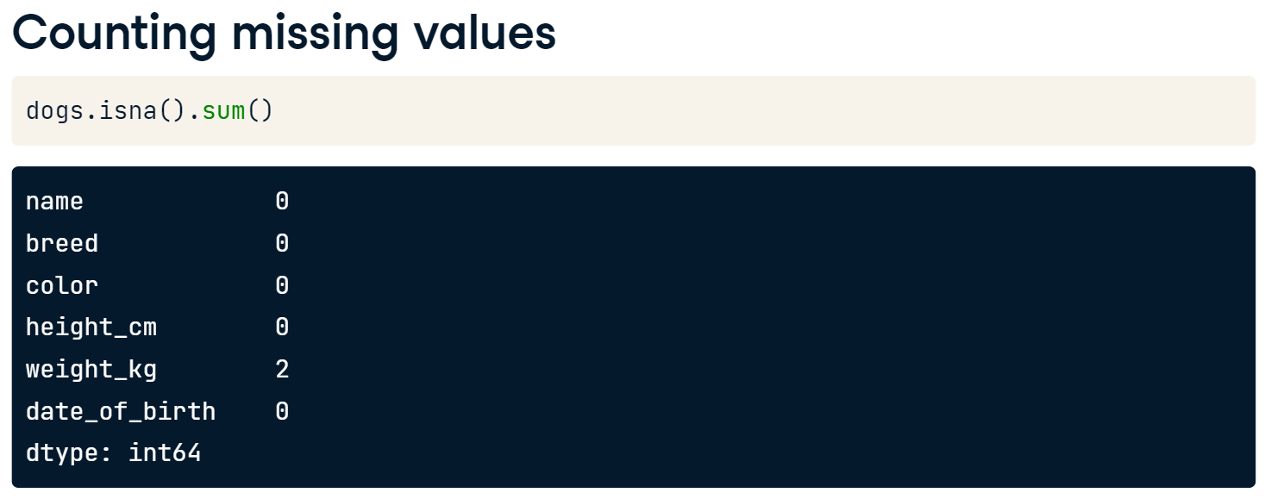
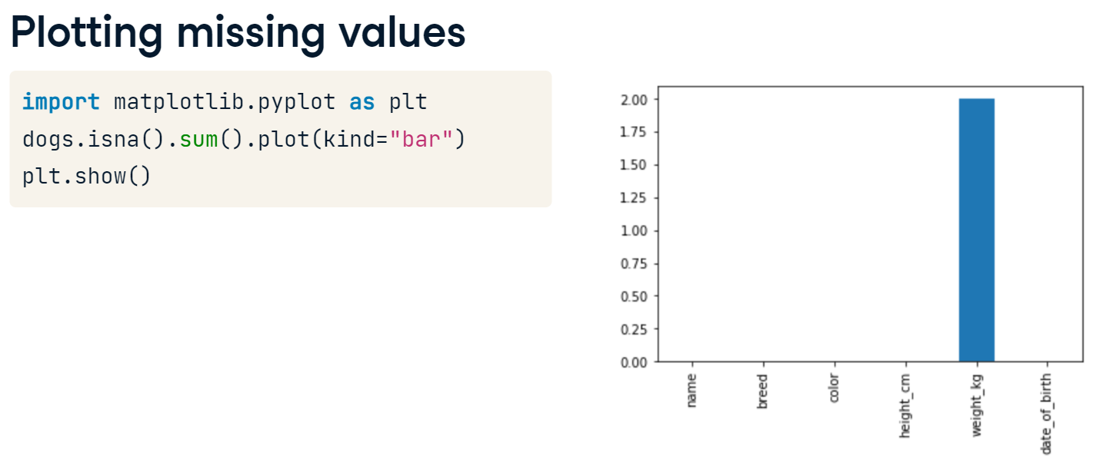
One option is to remove the rows in the DataFrame that contain missing values. This can be done using the dropna method. However, this may not be ideal if you have a lot of missing data, since that means losing a lot of observations.
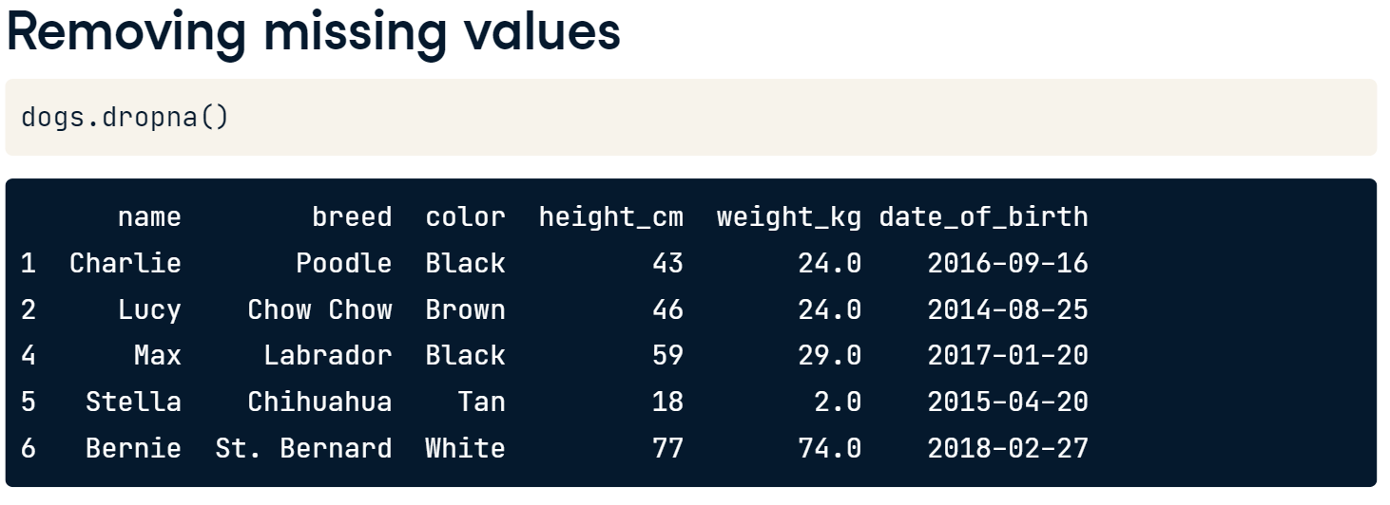

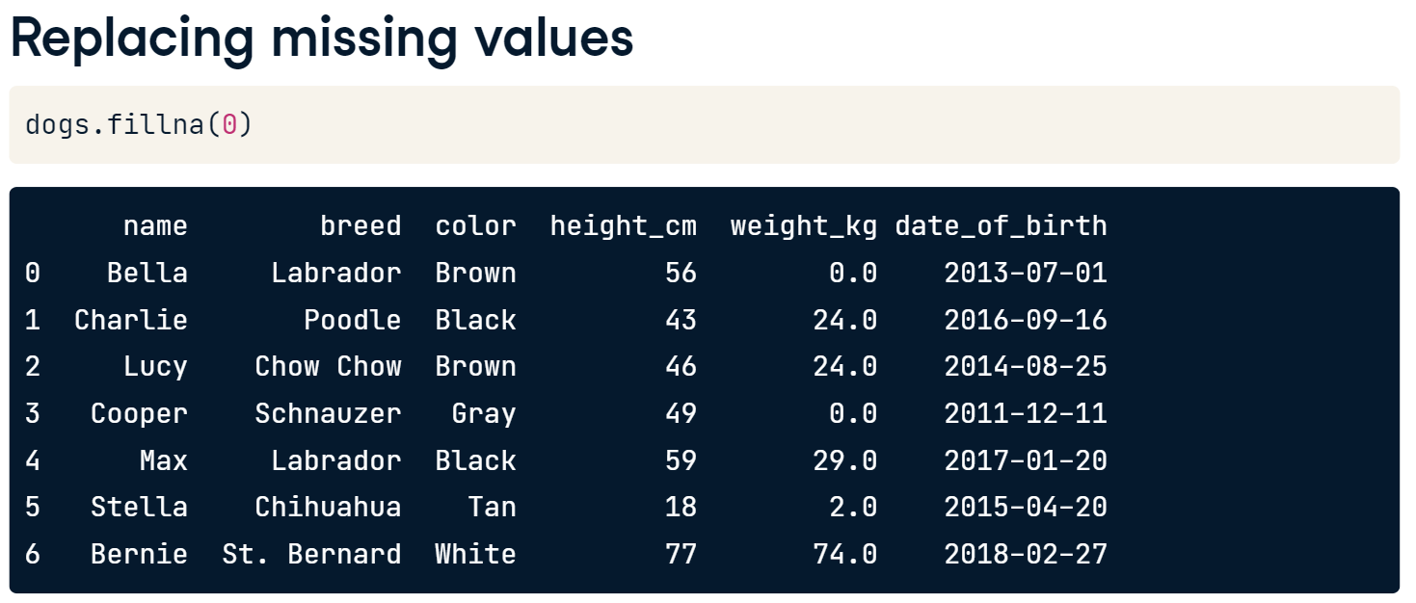
Import avocados_2016.csv to avocados dataframe and try
# Check individual values for missing values
print(avocados_2016.isna())

# Check each column for missing values
print(avocados_2016.isna().any())

# Bar plot of missing values by variable
avocados_2016.isna().sum().plot(kind = 'bar')

# Show plot
plt.show()

# Remove rows with missing values
avocados_complete = avocados_2016.dropna()

# Check if any columns contain missing values
print(avocados_complete.isna().any())

From WorldBank_GDP.csv, answer the following questions.
- Which country’s GDP is growing during the Year 2010 and Year 2018? Support your answer with visualizations.

From temperatures.csv, answer the following questions.
- Find out which country has the highest average temperature.
- Find out how many countries where the average temperature is in the range of 20 and 30 Celsius. Show all the countries and their average temperature.
- Show the average temperature of Thailand during 2005-01-01 and 2010-01-01 and also find the average temperature during that period.
